**Course 3**

# **Project Planning: Putting It All Together**

# **Project kick-off meeting**

A project kickoff meeting is the first meeting in which a project team comes together to ground everyone in a shared vision, gain a shared understanding of the project's goals and scope, and understand each person's individual roles within the team.

* Team
* Stakeholders
* Sponsor

**Agenda**

* Intro Purpose
* Background
* Goals and Scope
* Intended Outcome
* Roles
* Collaboration
* What Comes Next
* Questions

**Planning**

* Set the right time
* Set the right length
* Invite the right people
* Designate a notetaker
* Set an agenda

**Work breakdown structure**

* Start with the high-level, overarching project picture. Brainstorm with your team to list the major deliverables and milestones.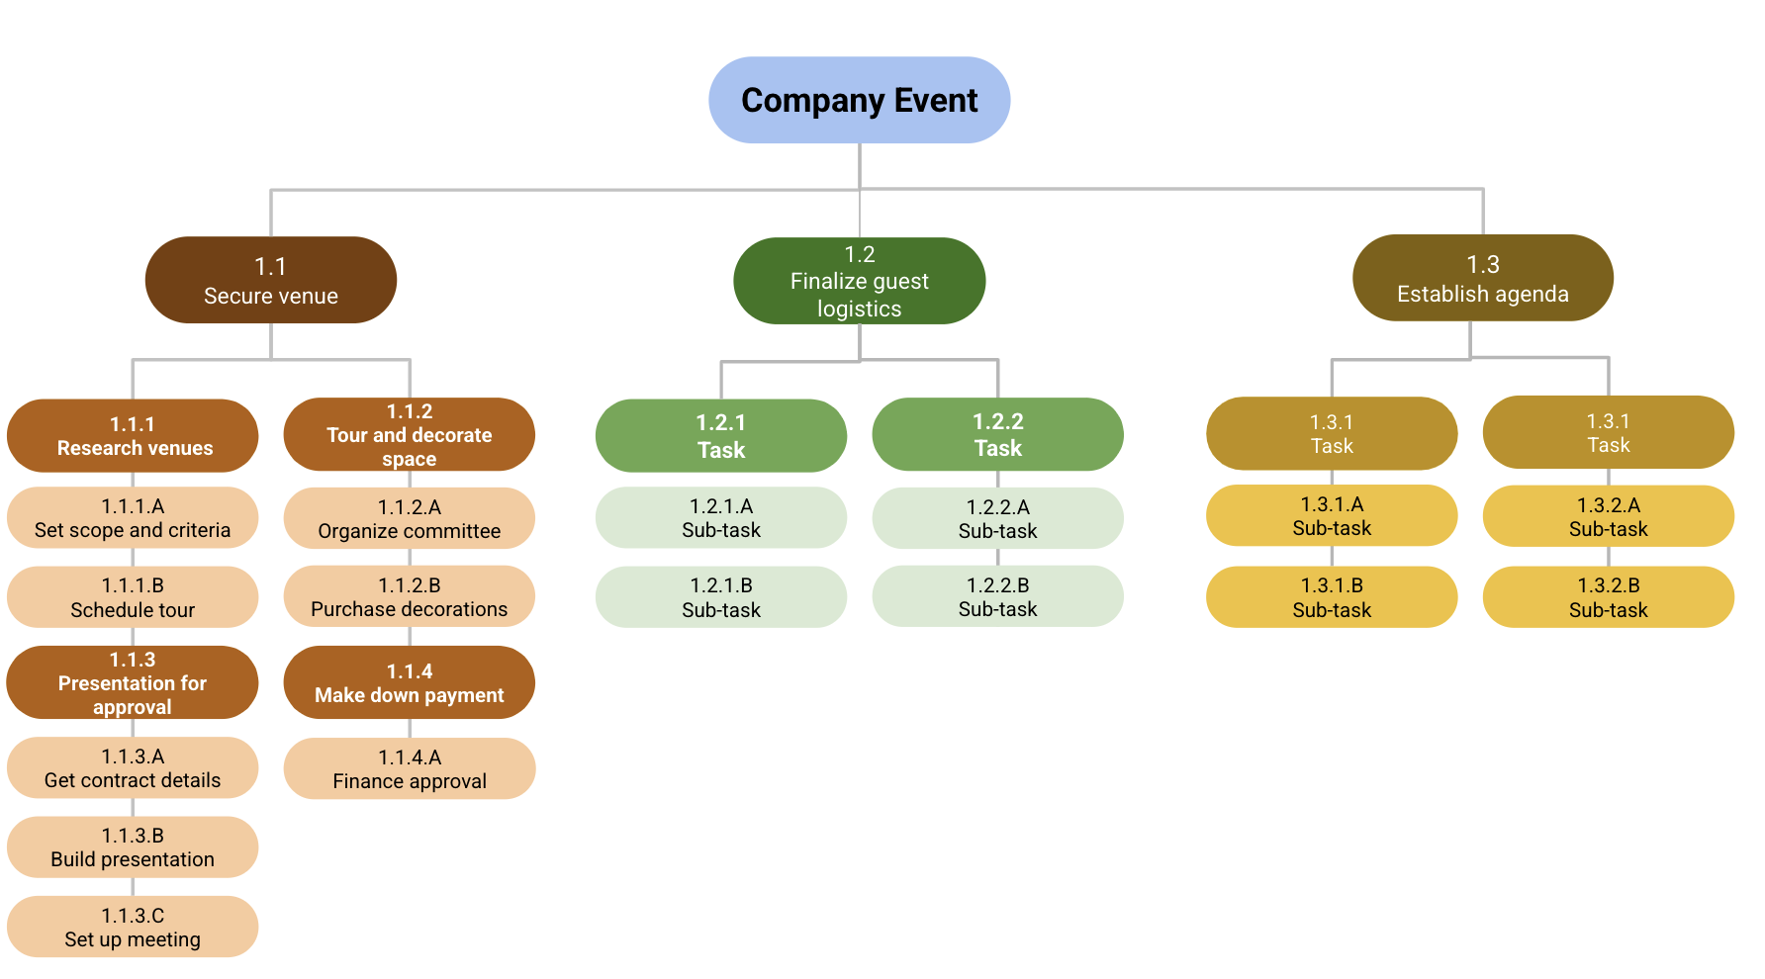
* Identify the tasks that need to be performed in order to meet those milestones.
* Examine those tasks and break them down further into sub-tasks.
* [Work Breakdown Structure (WBS) - Basic Principles](https://www.pmi.org/learning/library/work-breakdown-structure-basic-principles-4883)
* [How to Create a Work Breakdown Structure and Why You Should](https://www.lucidchart.com/blog/how-to-create-a-work-breakdown-structure-and-why-you-should)
* [Template - Work breakdown structure](https://drive.google.com/drive/folders/199nnPeuOhHoUUzZ1qlpxz8BKJtywXSFF?usp=sharing)

# **Project Plan**

**Components**

* Tasks
* Milestone
* People
* Documentation
* Time

**Essential project plan components**

* Scope and goals
* Work Breakdown Structure (WBS)
* Budget
* Management plans

**Creating a critical path**

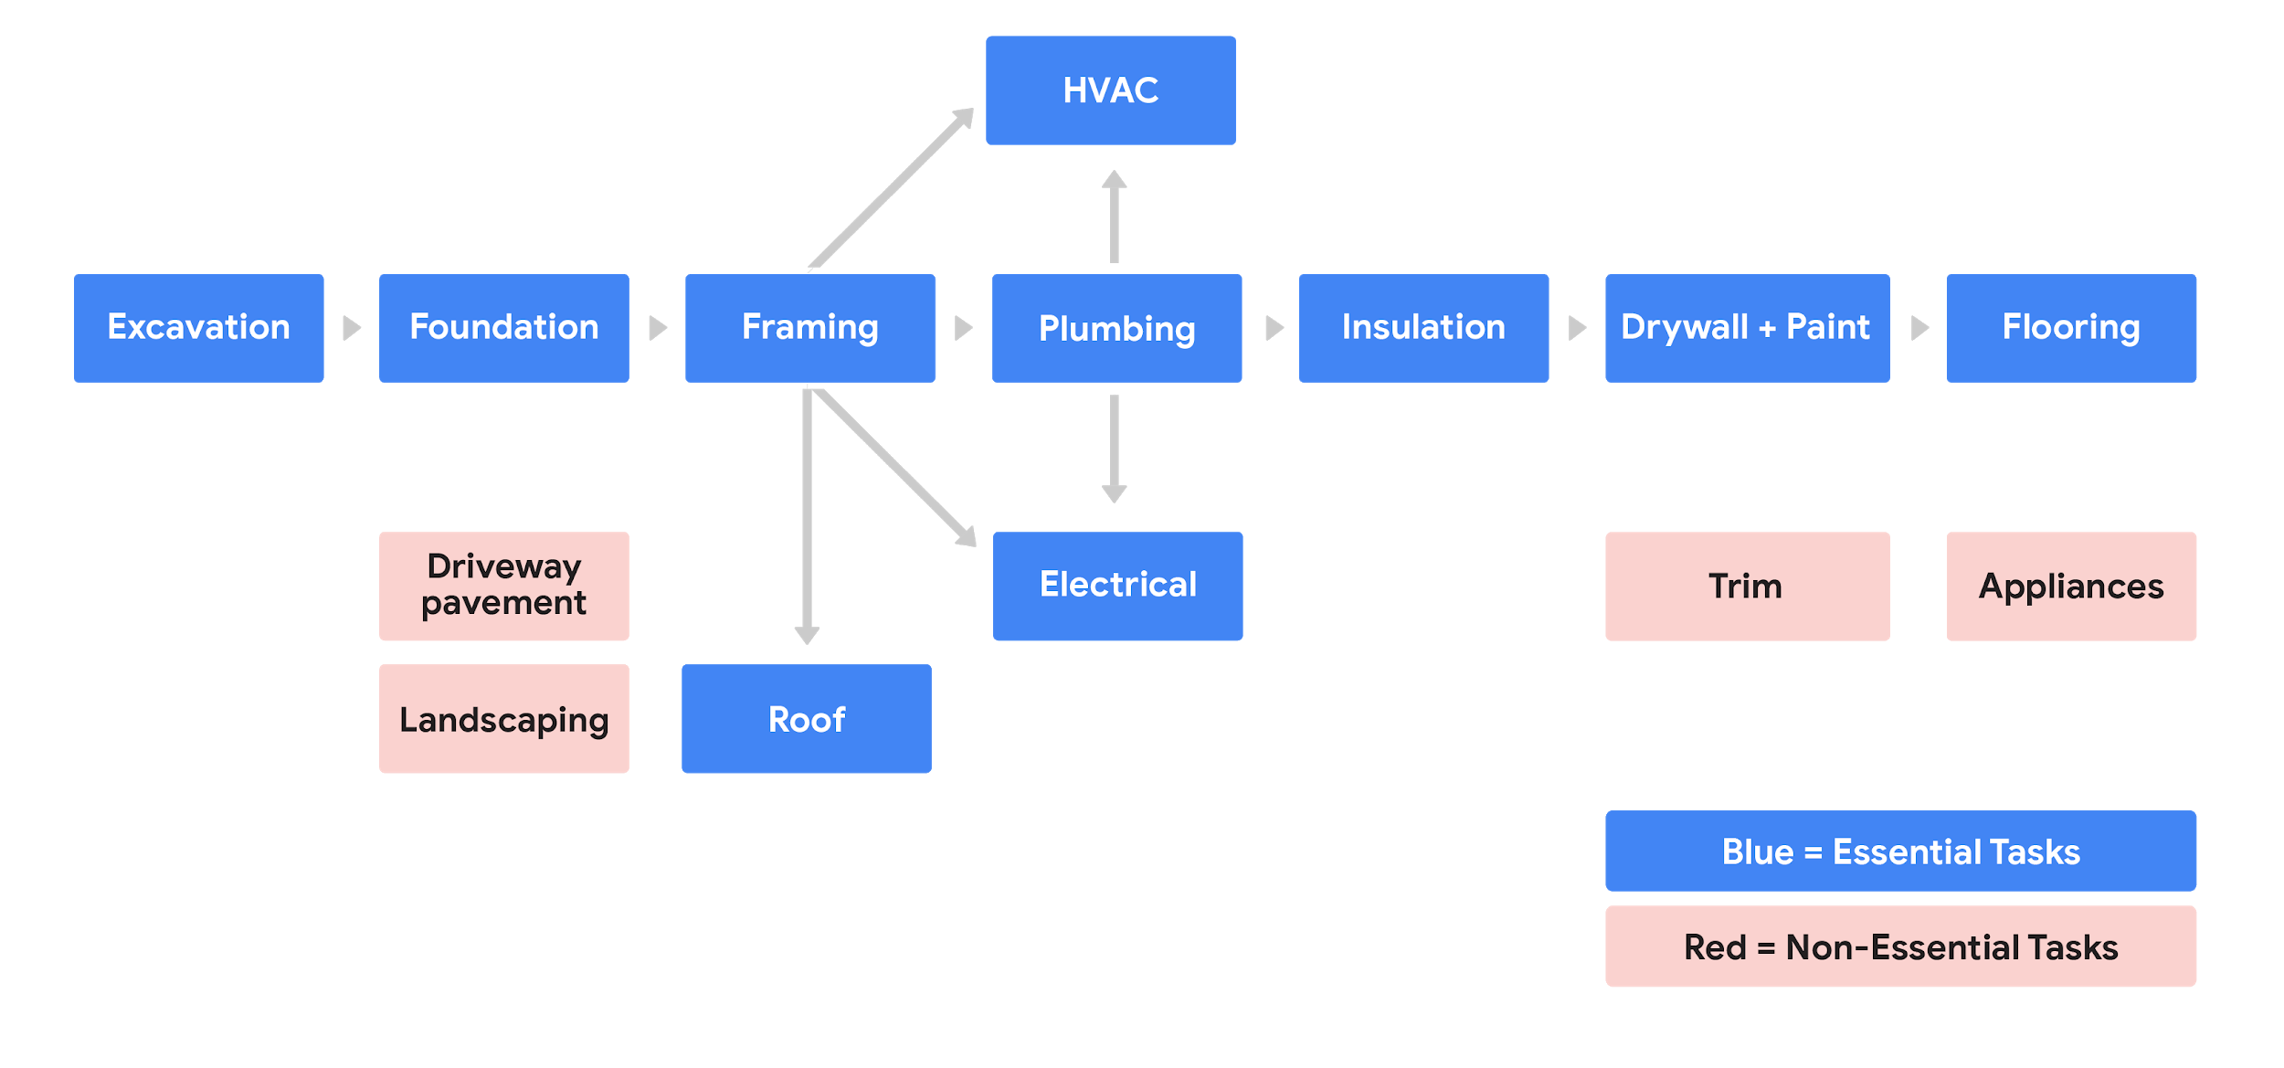

**Gantt Chart**

* [Smartsheet: Project Plan Templates for Microsoft Word](https://www.smartsheet.com/content/project-plan-templates)
* [Smartsheet: Project Plan Templates for Google Sheets](https://www.smartsheet.com/free-google-docs-templates-google-timeline-templates)
* [Google Project Plan Timeline Template](https://docs.google.com/spreadsheets/d/19mcHR1hq4NHqrW7HeGlSREbnMK-A8i0JbC5JwgInGCI/edit?usp=sharing)
* [Microsoft Gantt Chart Template](https://templates.office.com/en-us/simple-gantt-chart-tm16400962)

# **Project Budget**

**Tips**

* Reference historical data
* Utilize your team, mentors, or manager
* Time phase your budget
* Check, check, and double-check

**Components**

* **Fixed costs:** Costs that won’t change over the course of the project. They may include things like rent, insurance, office salaries, or travel.
* **Direct costs:** Costs that occur during your project; for example, labour costs for your team and materials required.
* **Indirect costs**: Costs that can’t be linked directly to a project, such as administrative costs. You may also see these referred to as overhead costs.
* **OPEX (operating expenses)**: Expenses that are required for day-to-day tasks within the company, such as contracted workers.
* **CAPEX (capital expenses)**: Expenses that businesses incur to create a benefit in the future; for example, full-time employees within the company.

**Budget Template**

* [Microsoft Excel Budget Templates](https://templates.office.com/en-us/budgets)
* [Microsoft Excel Website Budget Template (applicable to any project)](https://templates.office.com/en-us/website-budget-tm04035480)
* [Google Sheets Budget Template](https://docs.google.com/spreadsheets/d/1aPrP2tJcPrDeo9W0JR-I_hMMNxdPJ823X7AEGaqX2uI/edit?usp=sharing)

**Procurement process**

* **Initiating:** planning what you need to meet your project goals
* **Selecting:** deciding which supplies and vendors to use
* **Contract writing:** developing, reviewing, and signing contracts
* **Controlling:** making payments and maintaining and ensuring quality
* **Completing:** measuring your success

**Common procurement documentation**

* **NDA** (Non-disclosure agreement)
* **RFP** (Request for Proposal)
* **SOW** (Statement of Work)

[Template SOW (Statement of Work)](https://docs.google.com/document/d/1Nnqy70kD9VxEe9LO0z-_ZFxcUGJ8xsoIplifpMrYco8/edit?usp=sharing)

**Project Risk**

**Fishbone diagram/ Ishikawa diagrams / cause-and-effect diagram**

* Define the problem
* Identify the categories
* Brainstorm causes
* Analyze results

**Managing single point of failure risks**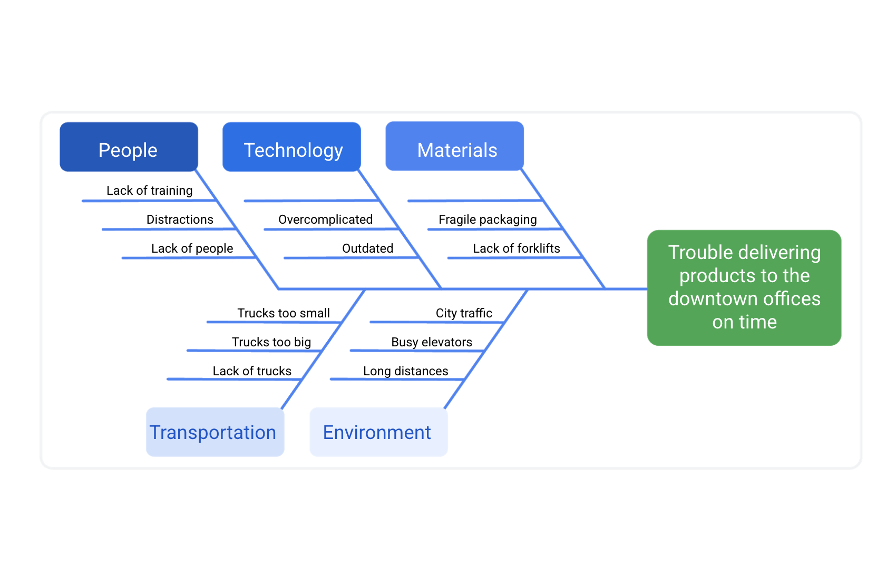

**There are four types of task dependencies**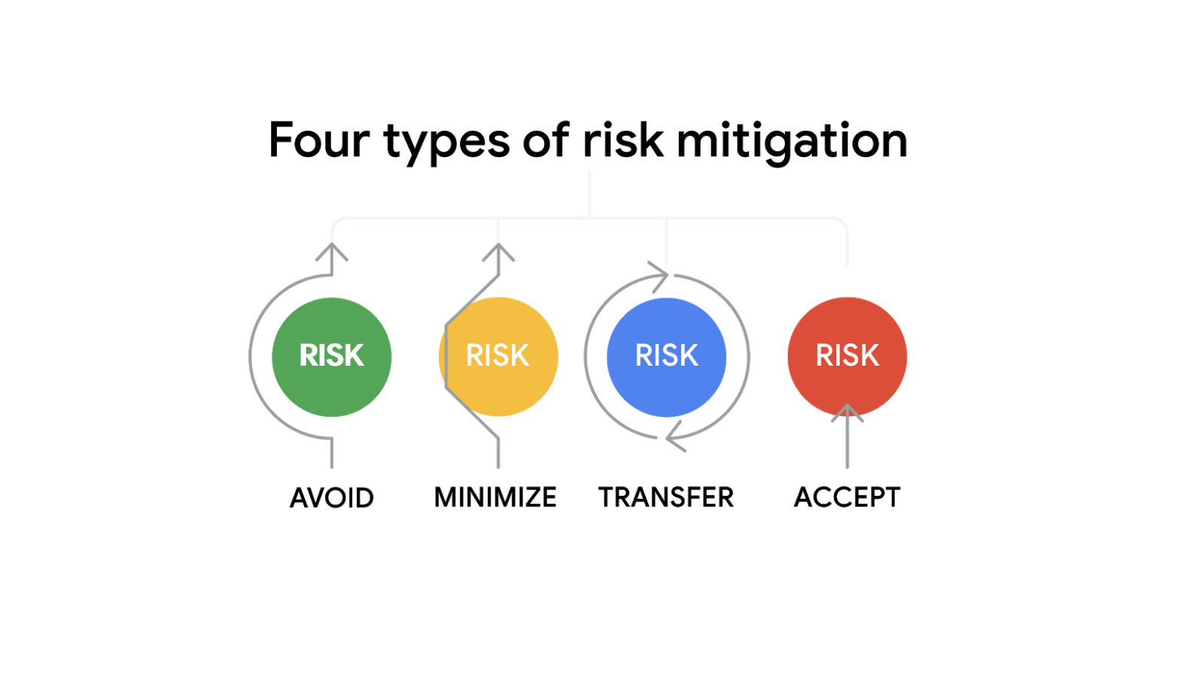

* Finish to Start
* Finish to Finish
* Start to Start
* Start to Finish

**Risk management plan**

[**Template | Risk Management Plan**](https://docs.google.com/document/d/1bGQnkapbtBfi63dviKEj2fnfRO4LomCXCKtwkAlSyU4/edit?usp=sharing)

# **Course 4**

**Project Execution: Running the Project**

# **Project Tracking**

* Gantt Chart
* Roadmap
* Burndown Chart

# **Project Dependencies**

* Internal
* External
* Mandatory or Legal
* Discretionary

# **Quality Management**

* Quality Standards
* Quality Planning
* Quality Assurance
* Quality Control

# **DMAIC**

* Define
* Measure
* Analyze
* Improve
* Control

# **PDCA**

* Plan
* Do
* Check
* Act

**Retrospective**

* Project Summary
* Key accomplishments
* Lessons learned
* Action items
* Future consideration
* Resources

**The six steps of data analysis**

* Ask
* Prepare
* Process
* Analyze
* Share
* Act

**Course 5**

# **Agile Project Management**

# **Project Budget**

**Four values of the Agile Manifesto**

* Individuals and interactions over processes and tools
* Working software over comprehensive documentation
* Customer collaboration over contract negotiation
* Responding to change over following a plan

**VUCA**

* Volatility
* Uncertainty
* Complexity
* Ambiguity

**Lean**

* Define Value
* Map Value Stream
* Create Flow
* Establish Pull
* Pursue Perfection

**The three pillars of Scrum**

* Transparency
* Inspection
* Adaptation

**The five values of Scrum**

* Commitment
* Courage
* Focus
* Openness
* Respect

**Product Backlog**

* Living Artifact
* Owned and adjusted by product owner
* Prioritized

**Product Backlog Artifacts**

* Item Description
* Order
* Value
* Estimate

**User Stories**

* Independent
* Negotiable
* Valuable
* Estimable
* Small
* Testable

**Backlog refinement**

**5 Stages of Sprint**

* Sprint
* Sprint Planning
* Daily Scrum
* Sprint Review
* Sprint Retrospective

**Value Roadmap**

* Product Vision
* Product Roadmap
* Release Plans

**Release Plan**

* Release Goals
* List of Backlog Items
* Estimated Release Date
* Other Impacts